**Name: Aditya Deepak Parkar (Automation SA2506029)**

**Java Assignment**

**Question 1) Write a Java program to reverse a string with and without reverse() function.**

Code:- Using reverse()

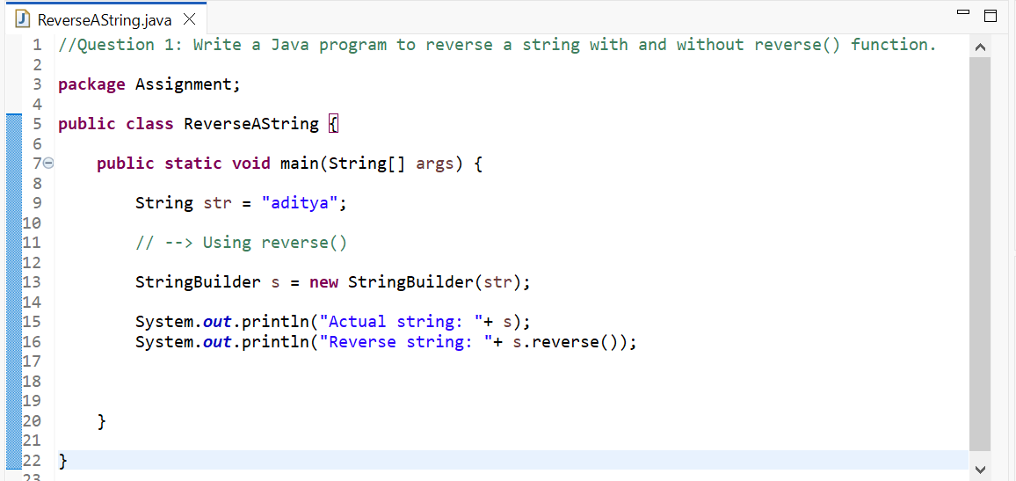

Output:-

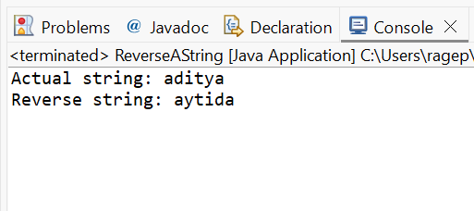

Code:- Without using reverse()

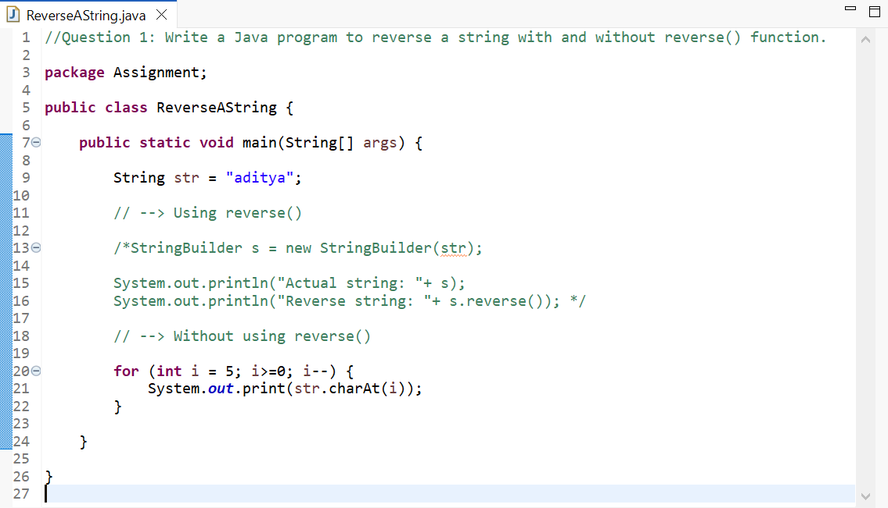

Output:-

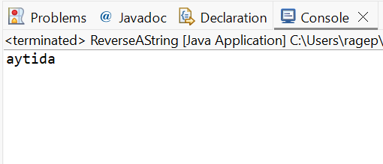

**Question 2) Write a Java Program to find prime numbers between 1 to 100.**

Code:-

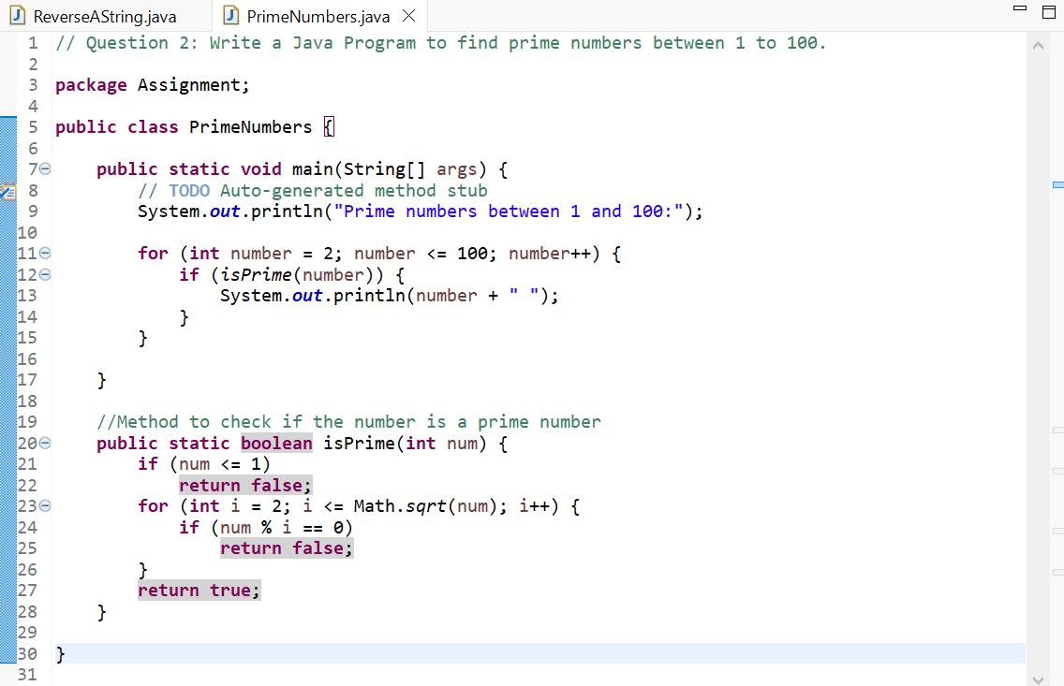

Output:-

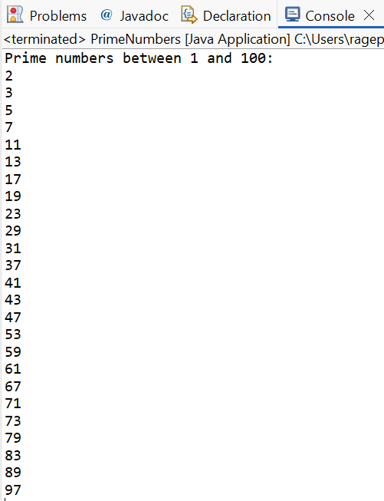

**Question 3) Write a Java Program to handle given uncheck exception**

**a) ArrayIndexOutOfBound**

**b) NullPointerException**

Code:- a) ArrayIndexOutOfBound

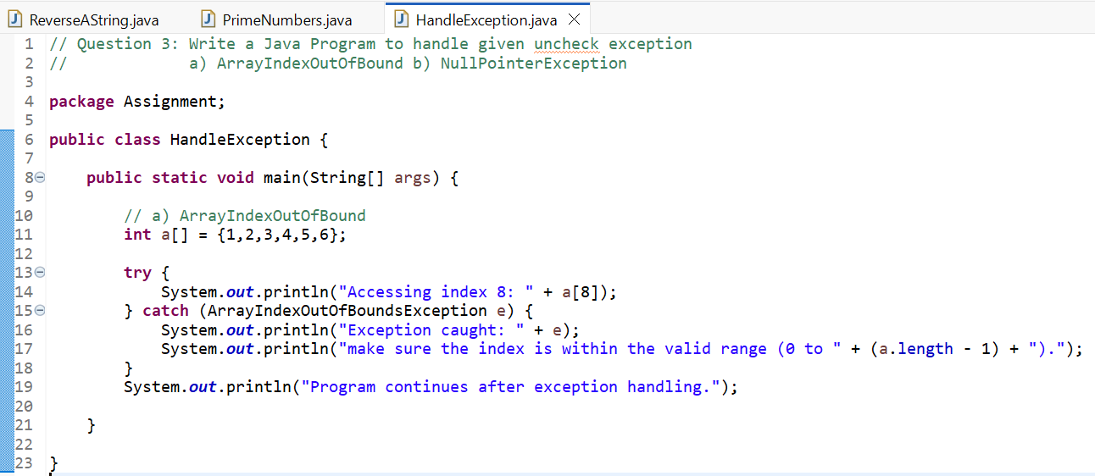

Output:-

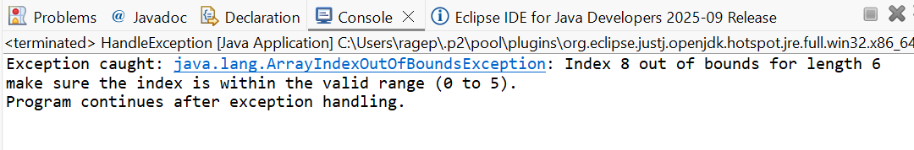

Code:- b) NullPointerException

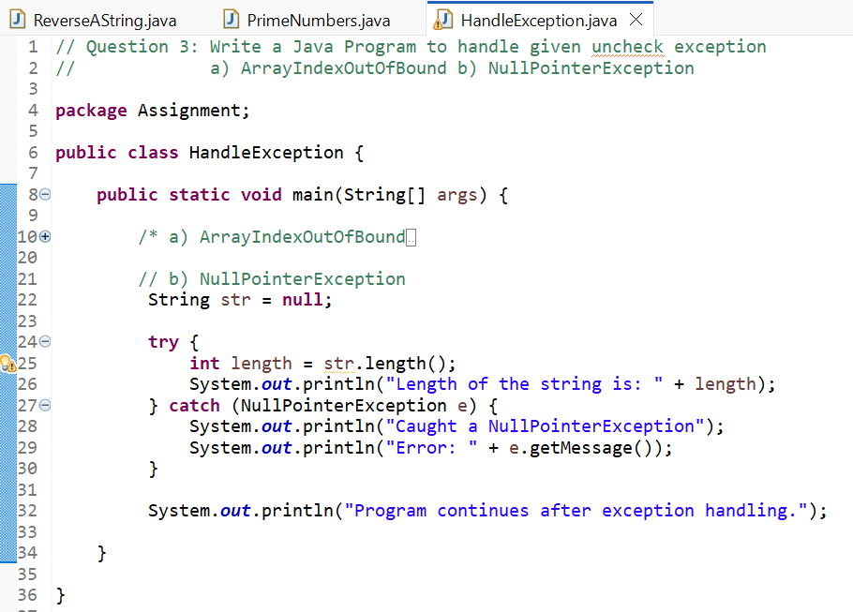

Output:-

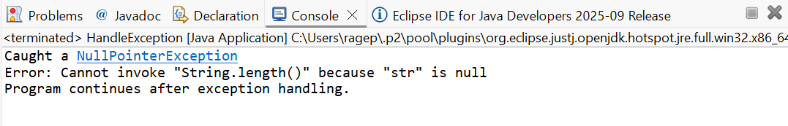

**Question 4) Write a Java Program to sort the ArrayList in Ascending order.**

Code:-

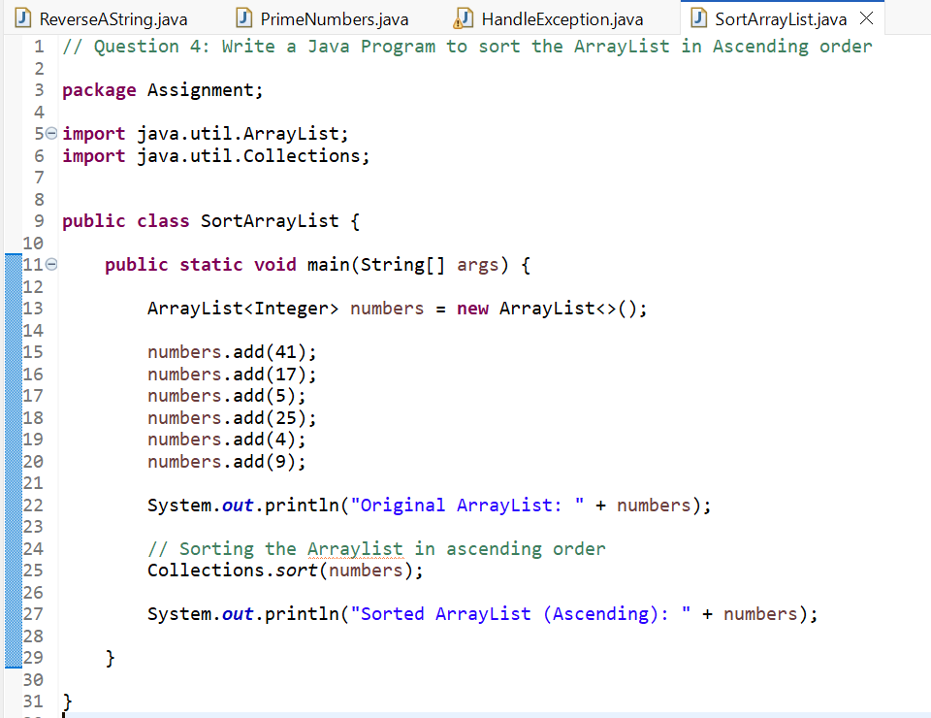

Output:-

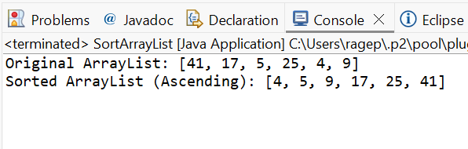

**Question 5) Write a Java Program to implement multiple inheritance.**

Code:- *Java does not support Multiple Inheritance using classes.*

